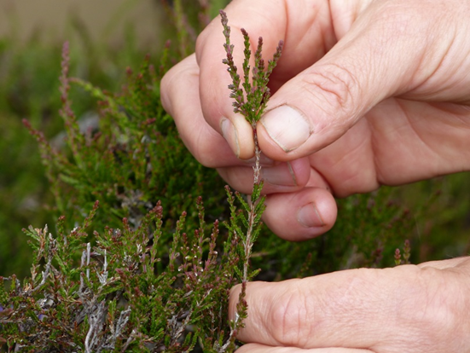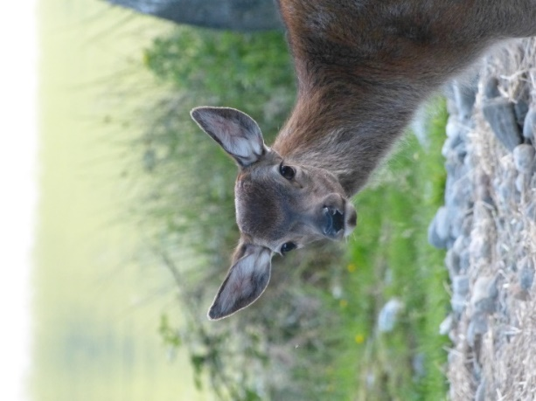

**Arran Habitat Impact Assessment**

**Summary of Herbivore Impacts on Dwarf Shrub Heath and Blanket Bog**

**2018/2019**



Prepared by:

**Dr Linzi Seivwright** BSc Phd

**Caorann**

Email: linzi@caorann.com

[www.caorann.com](http://www.caorann.com)

Table of Contents

1. Introduction 3

2. Methodology 4

3. Results 6

Table 1: Blanket bog Browsing and Trampling Impacts 2018 6

Table 2: Dwarf shrub heath Browsing and Trampling Impacts 7

Figure 1: Browsing impacts for Blanket bog and Dwarf shrub heath. 8

Figure 2: Trampling Impacts on Blanket bog 9

4. Discussion 10

*Table 3: Summary of Browsing and Trampling Impacts for Habitat as Actions.* 12

Figure 3: Trampling impacts and Stags 2014. 13

Figure 4: Trampling impacts and Hinds 2014. 14

Figure 5: Browsing impacts and Stags 2014 15

Figure 6: Browsing impacts and Hinds 2014 16

Figure 7: Relative vulnerability of habitats to under or over grazing. 17

5. References 18

APPENDIX 1: Photos Sannox 19

APPENDIX 2a: Blanket Bog Data 23

APPENDIX 2b: Dwarf Shrub Heath Data 24

**ANALYSIS OF HERBIVORE IMPACT HABITAT DATA ON DWARF SHRUB HEATH AND BLANKET BOG**

# 1. Introduction

**1.1 Arran Deer Management Group**.

Arran Deer Management Group area extends to just under 22,000 ha and covers the main open range for red deer on the island. The southern boundary of the group runs from just north of Brodick on the east coast on the island to Machrie on the western coast. There are four main members of the Group, which is operated as a single unit. Outwith the DMG area, there is a considerable area of enclosed forestry and farmland. A Deer Management Plan is in place from 2016 -2025.

The main objectives for the Group’s deer management that relate to this report are:

(i) To safeguard and promote deer welfare within the Arran DMG area

(ii) To achieve an appropriate balance between deer and their habitat, and between deer and other land uses, to minimize unacceptable damage to agricultural, forestry or sporting interests, and to maintain and improve the condition of the natural heritage.

As a part of the DMG’s ongoing commitment to carrying out environmentally responsible deer management in line with the [Code on Deer Management](http://www.snh.gov.uk/land-and-sea/managing-wildlife/managing-deer/code-of-deer-management/), over the last two years, a programme of herbivore impact assessment has been implemented in order to better inform future deer management.

**1.2 Herbivore Numbers**

Red Deer Population Foot counts have taken place in the spring time within Arran DMG on a consistent basis over many years. The count in 2016 showed a population of 661 stags, 853 hinds and 359 calves – an overall density of 10 deer km2.

There are approximately 1600 sheep within the boundaries of the Group, with the vast majority of these being on Sannox/ Arran estates, and many of these are constrained to lower ground grazings. Sheep numbers on Dougarie estate were reduced thirty years ago from 3000 to a modest number today. There are no sheep on NTS ground and there are no hill cattle reported within the DMG area.

**1.3 Designated Sites**

Upland designated sites dominate much of the DMG area, but the broad suite of habitats are listed as being in Favourable condition, with the exception of birch woodlands.

**1.4 Habitat Types**

The main vegetation types and approximate areas on each DMG property were calculated using Land Cover 88 vegetation data set.



**1.5 Habitat Monitoring**

Blanket bog and dwarf shrub heath are two of the habitats that Scottish Natural Heritage have recommended upland deer managers monitor for herbivore grazing and trampling impacts. The aim of this work was to set up plots and carry out an assessment of the current grazing and trampling impacts which will establish a baseline in order to monitor trends over time. Digital photography was also used to capture images of the sample plots to enable any future changes in the plot composition to be identified.

# 2. Methodology

**2.1 Field Survey**

Fieldwork was carried out over 2 years. A subset of plot coordinates was randomly selected from a total of 120 random points for each property generated by Scottish Natural Heritage for Blanket bog and Dwarf shrub heath type, using LCS88 vegetation data. Sample plots were located using a hand-held GPS receiver and plots were verified in the field. Plots were disregarded if they were not considered representative of habitat type.

The following plots were sampled:

* 46 Blanket bog sample plots were surveyed in 2018
* 56 Dwarf shrub heath plots were surveyed in 2019

A 2m x 2m plot (subdivided into 16 0.5m x 0.5m quadrats) was established at each location with a small wooden post marking the bottom right corner of the plot to enable the plot to be relocated. The right hand edge of the plot was orientated north using a compass. Two photographs were taken for each plot: one to identify the general location to assist future relocation, and one of the actual plot itself (Appendices 1). The plot was assessed according to amended* [Best Practice Guidance](http://www.bestpracticeguides.org.uk/) HIA methodology. A series of measurements and observations were recorded for each plot.

For Blanket bog these were:

* the average height of the dwarf-shrubs;
* the % of last year’s heather shoots that had been browsed ;
* browsing on cross-leaved heath;
* the frequency of quadrats with some bare peat showing;
* the proportion of those quadrants with bare peat that have evident hoof-prints;
* the frequency of quadrats with bogmoss present;
* the proportion of quadrats with bogmoss that have evidence of disruption including pulled moss or hoofprints.

For Dwarf shrub heath these were:

* the average height of the dwarf-shrubs;
* the frequency of quadrats with heather;
* the % of last year’s heather shoots that had been browsed ;
* evidence of broken heather stems indicating trampling.

Additional elements were noted including presence of sheep & deer dung, occurrence of muirburn and any other factor likely to contribute to the plot attributes. A summary of the data is contained in Appendices 2a, b.

**2.2 Calculation of overall herbivore impacts**

The assessment of herbivore impacts were scored on a scale from Low through Medium to High. Where heather wasn’t present in a plot, browsing impact on cross-leaved heath was used, with some browsing indicating a High impact.

# 3. Results

**3.1 Blanket Bog**

An overall herbivore impact for browsing and trampling was assigned to all 30 sample plots assessed in this survey (see Table 1 below).

Across the blanket bog, for browsing in 2018, 20 sample plots were in the Low (43%), 8 in Medium (17%) and 15 sample plots (33%) in the High class (Table 1 and Figure1).

For trampling, in 2018, 31 sample plots were in the Low and Low Medium impact classes (67%), 13 in the Medium (28%) class and 2 plots (4%) were found to have Medium High impacts (Table 1 and Figure 2).

## Table 1: Blanket bog Browsing and Trampling Impacts 2018



**3.2 Dwarf Shrub Heath**

An overall herbivore impact for browsing and trampling was assigned to all 56 Dwarf shrub heath sample plots assessed in this survey (see Table 2 below). For browsing 34 sample plots (61%) were in the Low class, 14 (25%) in the Medium classes, 8 (14%) sample plots in the High class (Table 2 and Figure1). For trampling, 39 (70%) sample plots were in the Low/Medium category and 17 (30%) plots were in the High category for heather stem breakage.

## Table 2: Dwarf shrub heath Browsing and Trampling Impacts



## Figure 1: Browsing impacts for Blanket bog and Dwarf shrub heath.

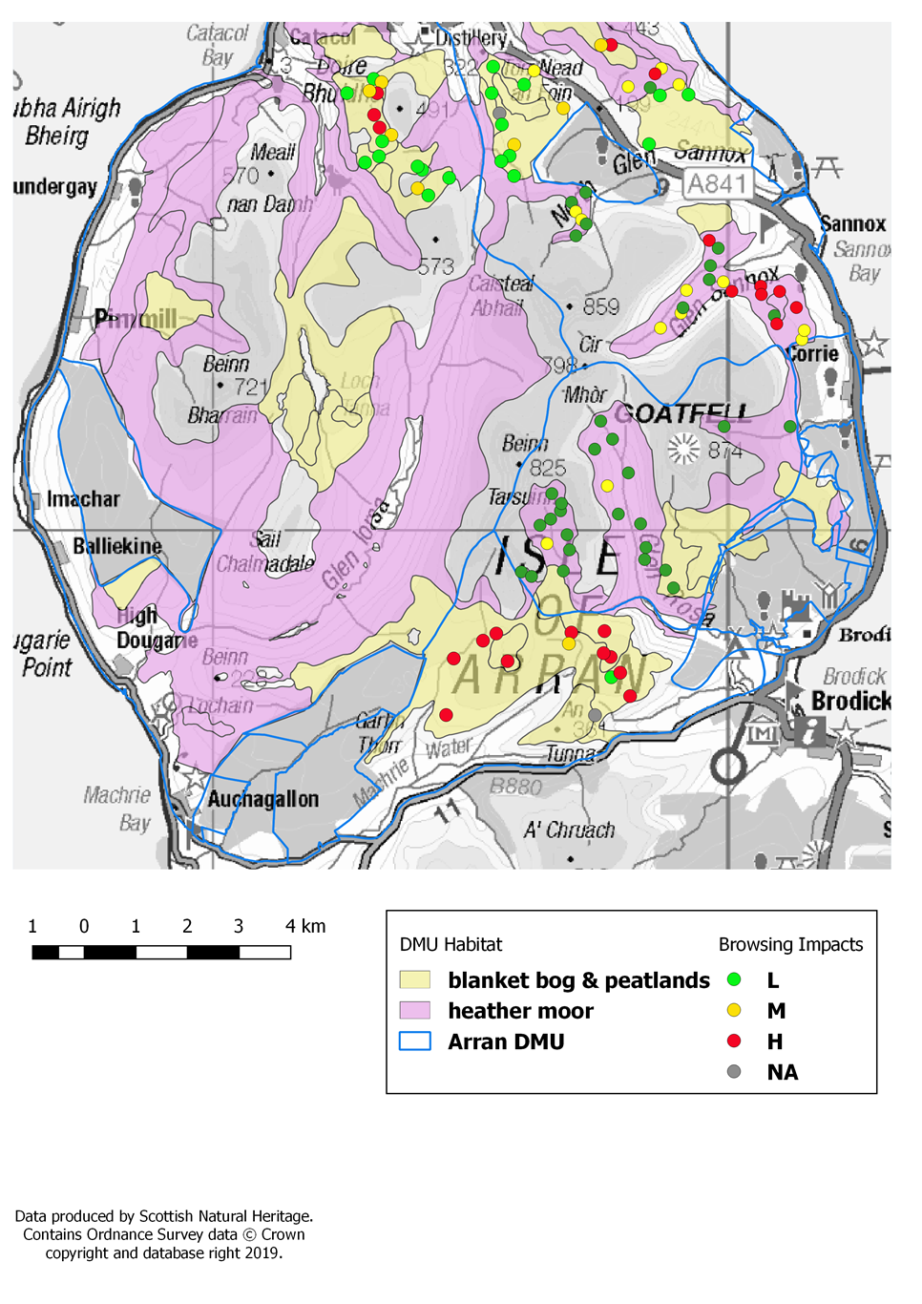

## Figure 2: Trampling Impacts on Blanket bog and Dwarf Shrub Heath

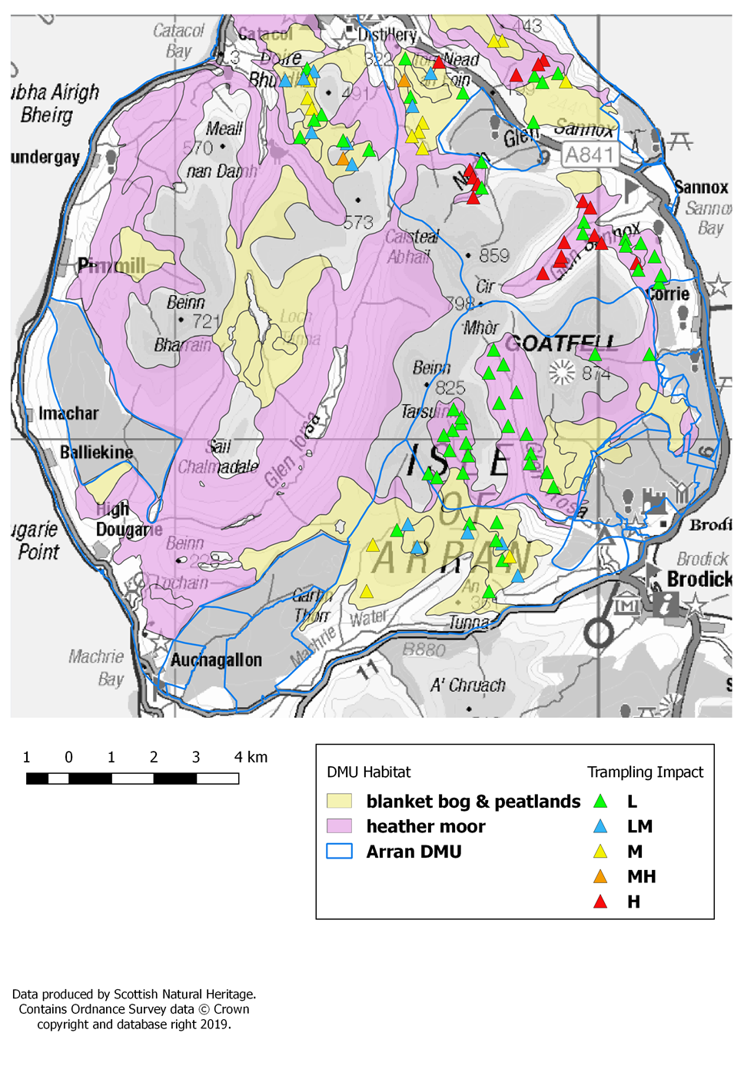

# 4. Discussion

**4.1 Determining Sustainable Levels of Grazing and Trampling**

Grazing and trampling impacts may affect different habitats differently. Impact levels that are acceptable for one community may be too great (or too low) for maintaining other habitats in the same area in favourable condition, resulting in need to compromise or prioritise habitats. For blanket bog and flushes in particular, trampling impacts may be of more immediate concern than the effects of grazing and damaging impacts may occur at a lower threshold of deer utilization or density than might be anticipated from consideration of grazing impacts alone (Dayton 2006). For Blanket Bog there may be negative changes resulting from moderate impacts, whereas for grassland communities, moderate or low impacts may not be desirable (MacDonald et al. 1998).

In contrast to woodlands, where unfenced native woodlands seem to regenerate naturally if there are fewer than 4–5 large deer per 100ha; open habitats may be much more ‘tolerant’ of grazing impacts before these may conflict with wider management objectives (Putman *et. al.* 2011). **At a landscape scale** for open range habitats other than smooth grassland, impacts on blanket bog, heathland, coarse grassland have been found to remain light or only light/moderate when deer densities are generally below seven or eight deer km-2 ( Albon *et. al.* 2007). Further work from 2016 HIA results carried out on Strathglass SAC, showed that for the 3 properties that met the 90% target for overall impacts falling in the Low to Low/Moderate range, overall density of deer on these properties ranged from 4.1 to 14.4 deer per km2.

For deer managers, the management of impacts is a key consideration and the management of deer populations (and other herbivores) is commonly used as a way to manipulate their impacts. However, research has shown that the relationship between large scale population density and **localised impacts** is a weak one. Recent research has shown that the activities of deer and other free-grazing herbivores are not distributed evenly across the landscape. The distribution and availability of key resources such as shelter, access to water as well as the quality and quantity of preferred vegetation types will all influence where, when and how the landscape is utilised (Moore *et. al.* 2015, 2018). Distribution may also be influenced by other factors such as human activity through disturbance, live-stock grazing or exclusion from preferred habitats This uneven pattern of distribution results in localised impacts on resources and this can have consequences (both positive and negative), both for the population as a whole and the wider ecosystem .

Effective deer management decisions to manage or reduce impacts will therefore have to consider more than just the overall population size and take full account of a range of factors in determining the appropriate stocking density for any given landscape. The appropriate overall stocking rate for a site will be dependent on the aims of management. To maintain good site condition, a balance must be achieved between the annual production of dry matter in the vegetation and the utilisation of this production by grazing herbivores. If the utilisation is too low, there will be a build-up of taller plants and dead plant material, while if it is too high there will be a loss of structural diversity in the vegetation. Both situations usually result in a loss of biodiversity. Realistic management targets must therefore acknowledge that in habitat mosaics, ideal levels of grazing cannot be maintained on all areas of all habitats simultaneously (Moore *et. al*., 2018).

**4.2 Summary and Actions**

Overall, the herbivore browsing impacts were found to be mostly Low on Dwarf Shrub Heath (61%) but mostly Medium and High on Blanket Bog (53%). High impacts on Dwarf Shrub Heath were localised in Sannox Glen and browsing impacts on Blanket Bog in the south of the DMG area.

Vegetation cover was found to be extensive in the quadrats sampled for both dwarf shrubs (96% of quadrats sampled) and sphagnum (bog moss) (86% of quadrats sampled).

Overall trampling impacts were mostly Low/Medium on Dwarf Shrub Heath (70%) but higher on Blanket Bog with 33% of plots showing Medium impacts and 3% plots showing Medium High impacts.

In order to examine impacts relative to deer distribution, count information from 2014 was used as a rough indication of deer distribution during the winter. Count maps are only a snap-shot in time but may indicate preferred areas for both stags and hinds. Impacts from 2018 and 2019 were mapped alongside count information from 2014 (Figures 3 to 6). Localised higher impacts tend to be found close to or on areas most frequently utilised by deer in winter.

A summary of impacts, impact targets, sustainable levels of grazing and trampling for each habitat are contained in Table 3. Consideration will be given by the Group as to what actions may help to tackle localised trampling impacts on Blanket Bog and Dwarf Shrub Heath. Repeat monitoring at a future date will allow the effect of impacts over time and any subsequent changes to be monitored, particularly with respect to vegetation cover.

*Table 3: Summary of Browsing and Trampling Impacts for Habitat as Actions.*

|  |  |  |  |  |  |
| --- | --- | --- | --- | --- | --- |
| ***Habitat Type*** | **Grazing Target** | **Current Impacts** | **Density of Deer at time of Survey** | **Sustainable Level of Grazing and Trampling** | **Actions** |
| *Blanket Bog* | Browsing Impact: 70% Low impact (<30% High  impact)  Trampling Impact: 70% low impact (<30% high  impact) | 37% of grazing impacts on Blanket Bog were found to be in the Low range and 40% in the High range.  64% of trampling impacts on Blanket Bog were found to be in the Low Range. No impacts in the High range. | The population was estimated to be around 10 deer per km2 in 2016. | Highest impacts were concentrated on the bog to the south of the DMG.  Moderate trampling impacts are localised in two or three specific areas and careful management should be considered to reduce these to acceptable levels. | To be agreed.  To be agreed. |
| *Dwarf Shrub Heath* | Browsing Impact: 70% low & mod impact (<30% high  impact)  Trampling Impact: 70% low & mod impact (<30% high  impact) | 61% of grazing impacts on Dwarf Shrub Heath were found to be in the Low range. 14% of impacts were in the High range.  70% of trampling impacts on Dwarf Shrub Heath were found to be in the Low Range | The population was estimated to be around 10 deer per km2 in 2016. | Current levels of impact at a density of 10 deer per km2 or less are close to being sustainable for both browsing and trampling. High grazing impacts were localised in the Glen Sannox area and future management should consider what actions might be required to reduce herbivore pressure in this area. | To be agreed. |

## Figure 3: Trampling impacts and Stags 2014.

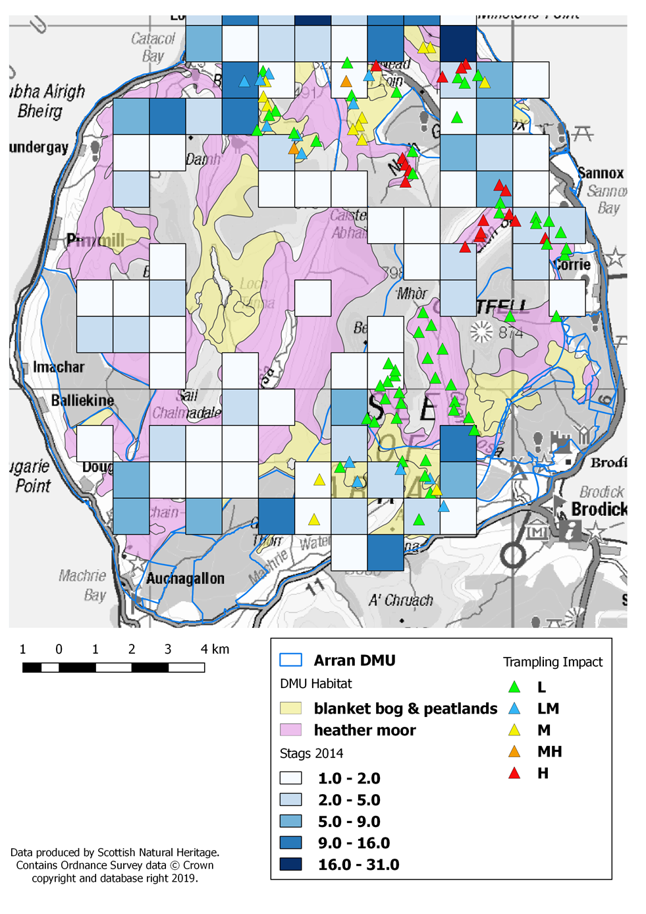

## Figure 4: Trampling impacts and Hinds 2014.

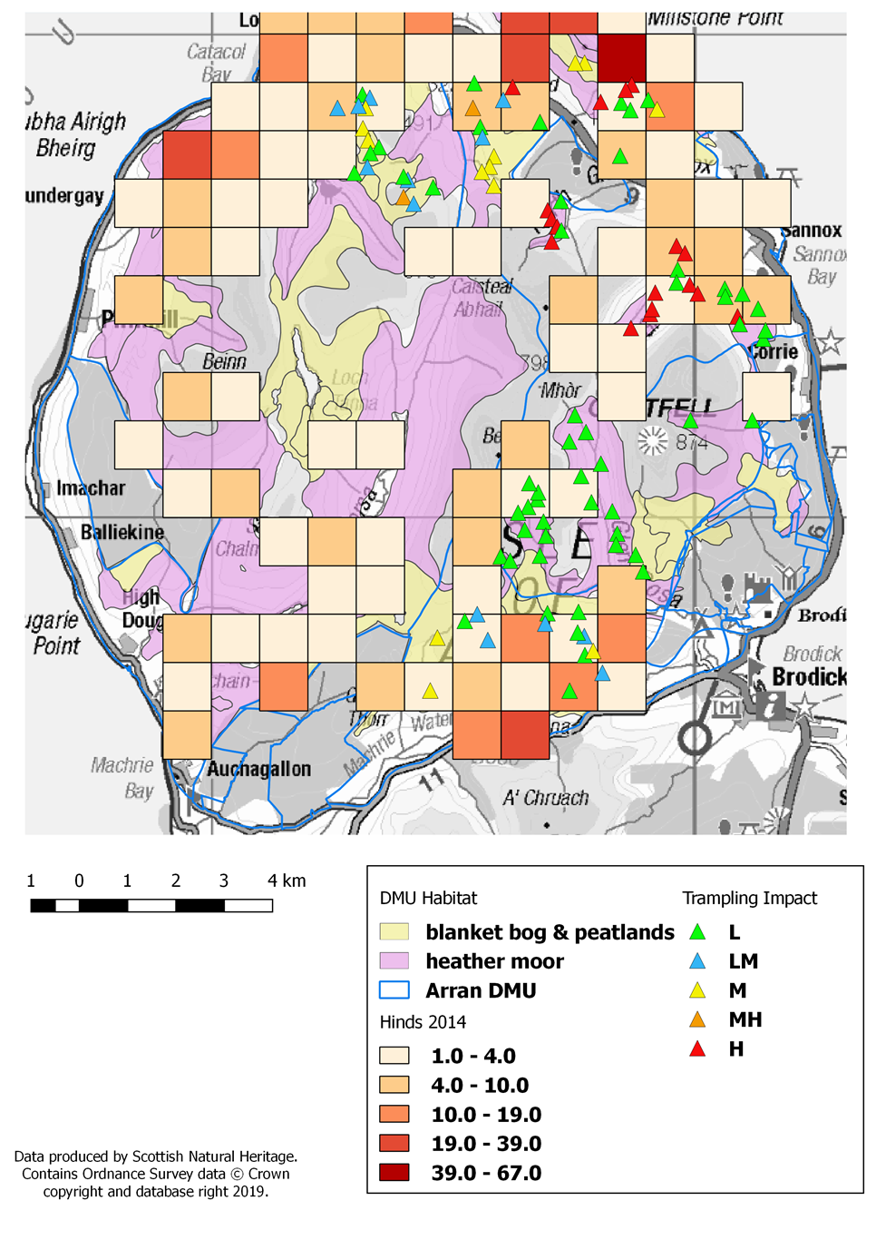

## Figure 5: Browsing impacts and Stags 2014

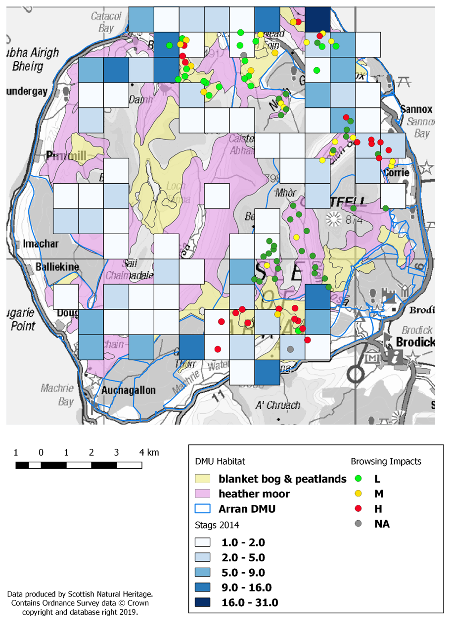

## Figure 6: Browsing impacts and Hinds 2014

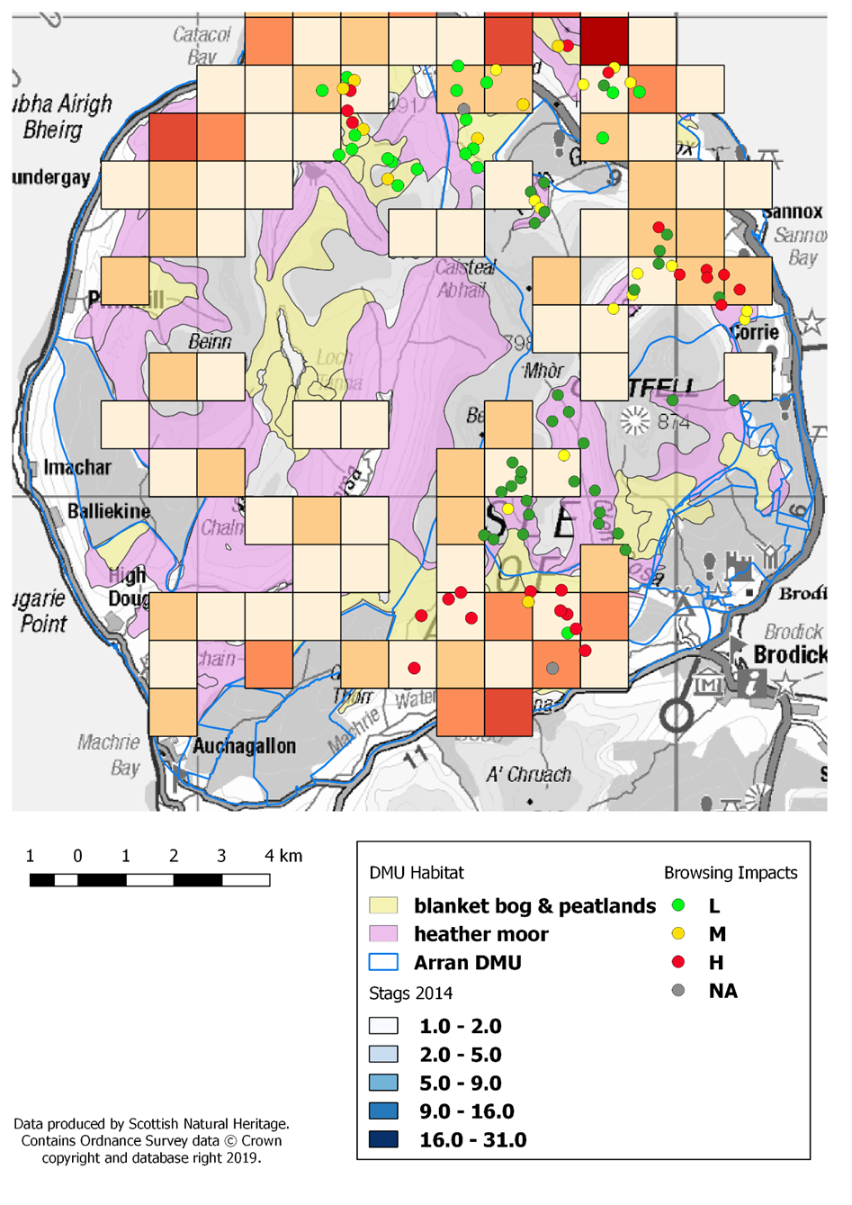

**4.3 Prioritisation of Habitats, Grazing Impacts**

Both Blanket Bog and Dwarf Shrub Heath a have a low/medium or medium vulnerability to overgrazing (Figure 9) with neither being vulnerable to under grazing. Neither habitat at this time requires management that will compromise the other i.e. increased grazing impacts to improve condition. Specific estates will consider actions to reduce localised impacts where possible and practical to do so.

## Figure 7: Relative vulnerability of habitats to under or over grazing.

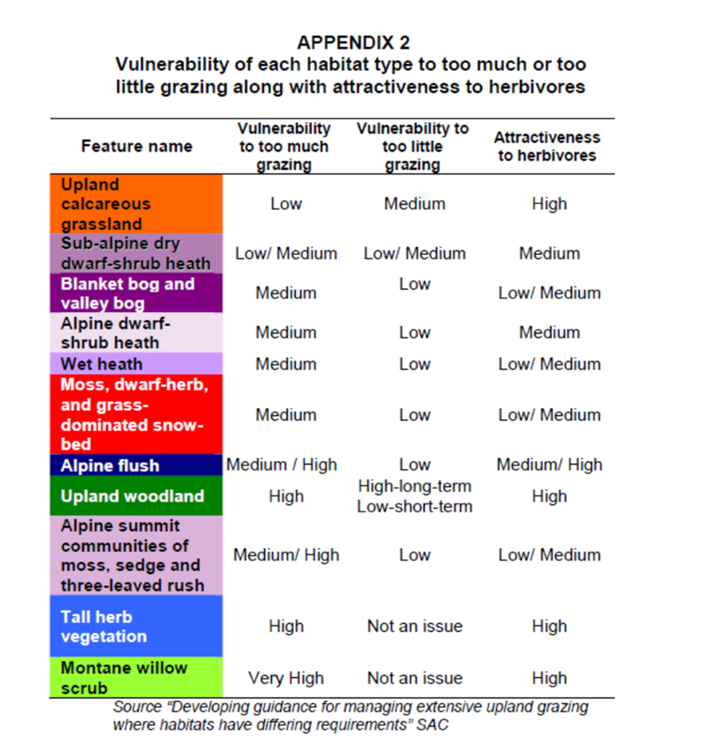

# 5. References

Arran Management Plan. (2016) Victor Clements.

Albon SD, Brewer MJ, O’Brien S, Nolan AJ, Cope D (2007) Quantifying the grazing impacts associated

with different herbivores on rangelands. *Journal of Applied Ecology* 44: 1176–1187.

MacDonald, A., Stevens, P., Armstrong, H., Immirzi, P. & Reynolds, P. (1998). *A Guide to Upland Habitats Surveying Land Management Impacts*. 2 Volumes. Battleby, Perth, SNH Publications.

Moore, E., Iason, G. Pemberton, J., Bryve, J., Dayton, N. Britton, A. & Pakeman, R. (2018). Habitat impact assessment detects spatially driven patterns of grazing impacts in habitat mosaics but overestimates damage. *Journal for Nature Conservation 45 (2018) 20–29.*

Moore, E. K., Britton, A. J., Iason, G., Pemberton, J., & Pakeman, R. J. (2015). Landscape scale vegetation patterns influence small-scale grazing impacts. *Biological Conservation, 192, 218–225*.

Putman, R. Langbein, J., Green, P & Watson, P. (2011). Identifying threshold densities for wild deer in the UK

above which negative impacts may occur. *Mammal Review*.

Wild Deer Best Practice Guidance (2008) Deer Commission for Scotland.

# APPENDIX 2a: Blanket Bog Data



# APPENDIX 2b: Dwarf Shrub Heath Data

